 | TECHNICAL CHAMBER OF GREECE (TEE)
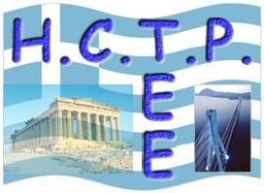 | HELLENIC CONSTRUCTION TECHNOLOGY PLATFORM (HCTP)
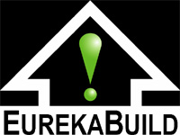 | EUREKABUILD

REGISTRATION FORM

EurekaBuild Workshop & Brokerage Event
“Towards a Sustainable Built Environment & a Living Cultural Heritage”

21 May 2007, Athens, Greece
Location: “Leonidas Zervas” amphitheatre, National Hellenic Research Foundation, 48 Vasileos Konstantinou Ave., Athens, Greece

I intend to participate in the EurekaBuild Workshop & Brokerage Event, 21 May 2007 | ◻
I intend to send a EurekaBuild Project Idea Form | ◻
I intend to present a poster of research findings / works / materials of my institute / company | ◻

First Name
Last Name
Title
Position
Company/Institute etc.
Address
City
Country
Tel.
Fax
E-mail

To be returned by e-mail to: akonsta@mail.ntua.gr (Mrs Agoritsa Konstanti) until 24 March 2007.

